Varian Magnet Instructions:

- Turn on cooling water. Let magnet cool for a couple minutes
- Turn on magnet power source (located on ground by far wall)
  - It should make a large sound
  - For operating purposes make sure the vacuum bulbs light up on the inside of the large power console. If they light up you are good to go
  - If these do not light up, try turning off the power and make sure both of the plugs in the back of the large power console are connected well. Try pushing them in or wiggling them around and turning the power back on to see if the bulbs light up.
  - If they still don’t you might have blown a fuse. There are extra fuses in a Ziploc baggie on top of the large power console. Make sure to UNPLUG everything when replacing the fuses. The fuses can be pulled directly out with pliers.
- Give the magnet power console a few minutes to warm up before turning on the high voltage switch (DO NOT TURN ON HIGH VOLTAGE UNTIL STEP 10)
- Make sure all connections are properly set up
  - Make sure Hall probe is perpendicularly placed inside the magnet, probably just with tape
  - HALL PROBE DIAGRAM
  - 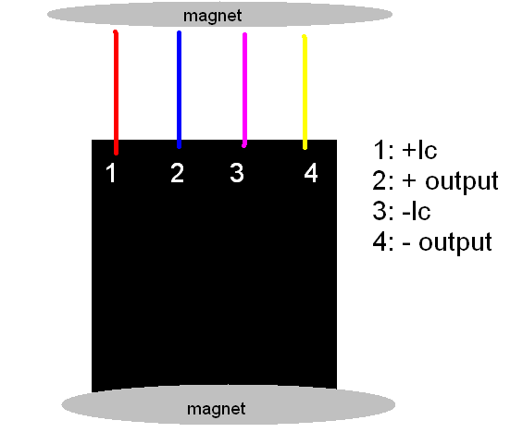
  - Max current for hall probe power in is 10 mA, should be set a 6 mA. Has a input impedance of 690 Ω and an output impedance of 2.37 kΩ
  - Data sheet located in front pocket of Magnet/Vacuum pink binder
  - The wires go into a circuit box and are connected to BNC connectors
  - Plug in the BNC wire from the Power-one Voltage Power source to the BNC connector labeled POWER
  - Plug in the BNC wire from the FLUKE multimeter to the OUTPUT BNC connector
  - Make sure a BNC wire is connected from the DAC0 analog output from the DAQ board and runs into the magnet power console
- While waiting for the power console, turn on the FLUKE multimeter by pressing the power button
  - Make sure the red taped connector is in the HI red input
- Plug in the Power-one voltage power source to the wall to the right of the computer. This device has a mesh wire back cover.
  - Make sure the +5V pin and the 5V RTN pins are connected to the 78L05 voltage regulator which is taped on the side of the FLUKE multimeter.
  - There is 5.02 +/- 0.02 V coming out of the power source and 4.17 +/- 0.02 V coming out of the voltage regulator giving a total current of 6 mA which is a comfortable current for the hall probe.
  - DIAGRAM FOR 78L05 VOLTAGE REGULATOR
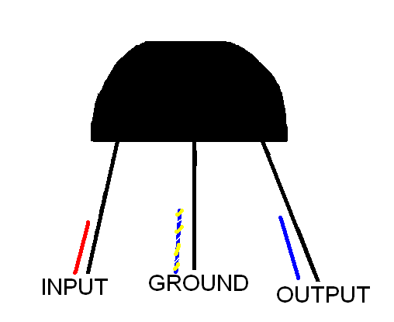
- Open the LabVIEW programs
  - Browse under LabVIEW>>INSTRUMENTS>>VARIAN MAGNET
- Open the program “Initialize Multimeter”. All of the settings should be auto set, if not here are the settings:
  - GPIB 2
  - Function- volts DC
  - Rate- fast
  - Range- autorange
  - Trigger mode- internal
  - Run the program and then close it
- Open the program “Go to field (stable)”. The best PID numbers are:
  - P= -350
  - I= -12
  - D= -1
  - These numbers are negative because the incoming voltage is negative
  - In the go to field slot, place a small number like 0.1 T for when the magnet turns on
- Flip on the High Voltage switch on the large power console
  - If it makes a large buzzing noise immediately turn off and turn on again
  - Make sure the Current does not go over the 1.3 mark, this is where the fuses will blow out
- Run Go to Field (stable) program to make sure everything works!
- Max field is set to 0.9 T

Turning off the magnet
- Turn the high voltage switch off
- Turn the magnet power off
- Turn all corresponding electronics off
- Turn the water off

